*Lab report – 3*

*Visual Search Task*

*PSY310: Lab in Psychology*

*Nirja Sukhadia*

*AU2120057*

*Github Link –*

**Introduction**

We use visual search in our daily life, for example, when we are looking for any specific vegetable in the supermarket, when we are searching for a particular series or movie on Netflix, etc. Hence it is clear that visual search is a technique that we use daily to look for a particular target among distractors. In this experiment, participants are supposed to identify and locate the target among various distractors, and examine the factors affecting search time and accuracy. By examining these factors visual search task aims to understand attention, perception and search efficiency. Visual search task uses reaction time to understand attention and efficiency of the person. Attention of the person while doing the task determines the efficiency of the visual search task. The more attention the participant is giving to the task the more accurate and efficient the responses are. If the reaction time slope is steeper, then the responses are inefficient and require more attention and vice-versa. (Jeremy M Wolfe, 2017).

**Method**

There were 5 participants of 21 years old and enrolled in Ahmedabad University were recruited The experimental setup was designed on PsychoPy software on a 16” laptop. The experiment consisted of a cross fixation at the centre of the screen, one target presented as, T and distractors presented as, L; of randomly chosen orientation between 1 to 360 degrees. The experiment was conducted for 200 trials per participant. The number of distractors are randomly chosen between 5 and 10, to see the difference in reaction time. The participants were supposed to identify the target (T) and click on it, as the response. PsychoPy records the mouse_time which is the time taken by the participants to find the target and click on it.

**Result**

The data collected by Psychopy is firstly cleaned by removing the unnecessary columns and sorting the remaining ones, which consisted of number of distractors and mouse_time. Following are the tables that display the average mouse time (average reaction time) –

Average of RT when presented with set size 5 -

|  |  |
| --- | --- |
| **Participant** | **Average RT** |
| 1 | 2.519295196 |
| 2 | 2.81723724 |
| 3 | 5.54607137 |
| 4 | 2.15962819 |
| 5 | 1.90804428 |
| **Set size 5 Mean** | **2.990055255** |

Average of RT when presented with set size 10 -

|  |  |
| --- | --- |
| **Participant** | **Average RT** |
| 1 | 2.835746483 |
| 2 | 3.093682394 |
| 3 | 5.796196363 |
| 4 | 2.67447897 |
| 5 | 2.48553539 |
| **Set size 10 Mean** | **3.37712792** |

Then the slope of both these averages was calculated using the formula m= (y2-y1)/(x2-x1), which is equal to 77.414 ms/distr. The graphical representation of the same is shown below –

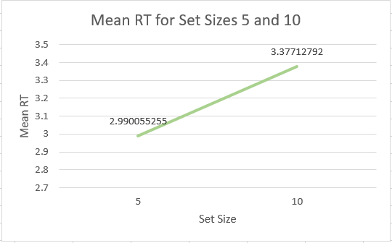

*Graphical representation of the Slope.*

**Discussion**

The slope gives us the relationship between the set size i.e, the number of letters on the screen and the reaction time taken by the participant to find the target. As we can see the slope is positive indicating that as the set size increases the reaction time also increases as higher the number of distractors reduces the participants’ visual search efficiency and hence take longer to find the target. The difference between the reaction time of two set sizes, 5 and 10 clearly show the same. The steepness of the slope indicates the amount of effectiveness and the rate of processing for the response selected.

# References

Jeremy M Wolfe, T. S. (2017). Five Factors that Guide Attention in Visual Search. *National Library of Medicine*.